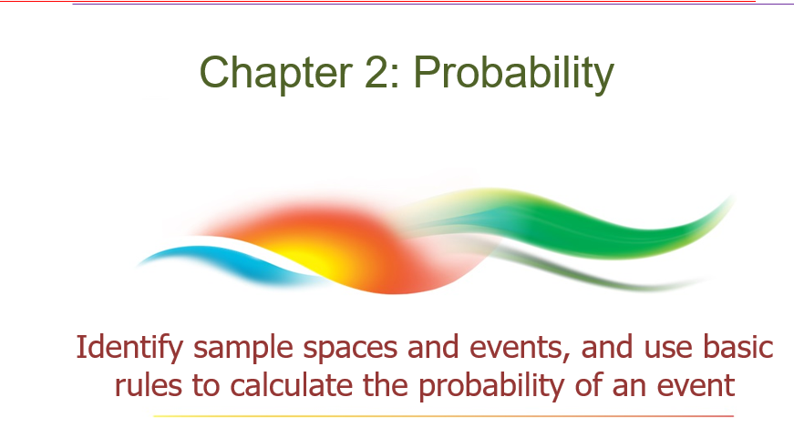

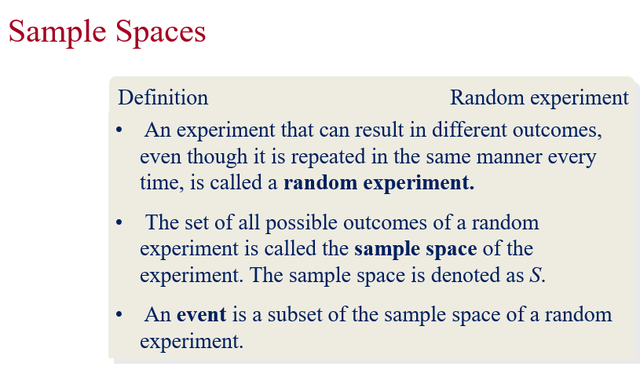

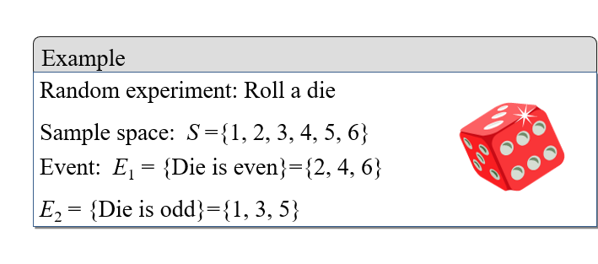

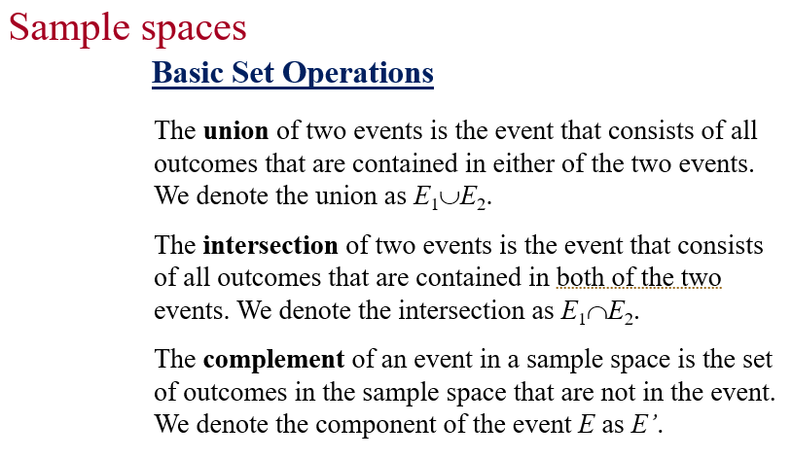

Ex: $S=\left\{1, 2,3 ,4,5 ,6\right\}$
$$E_{1}=\left\{1, 4,5\right\}$$
$$E_{2}=\left\{2,4,6\right\}$$
$$E_{1}∪E_{2}=\left\{ 1 2 4 5 6\right\}$$
$$E_{1}∩E_{2}=\left\{4\right\}$$
$$E_{1}^{'}≔S-E_{1}=\left\{2 3 6\right\}$$
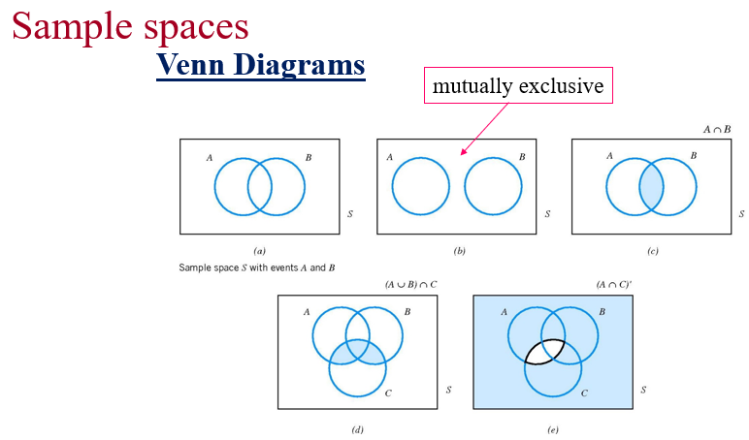

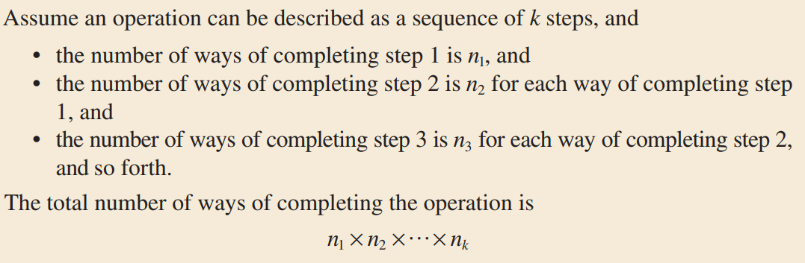
$$X=\{0,1,2,3,4,5,6,7\}$$
How many numbers of 3 distinct digits $\overline{abc}$ can be created from X?
+ a: 7
+ b: 7
+c: 6
- 7*7*6

$$X=\{0,1,2,3,4,5,6,7\}$$
How many even numbers of 3 distinct digits $\overline{abc}$ can be created from X?
Case 1: $\overline{ab0}$ 7*6 =42
Case 2: $\overline{abc}, c∈\{2, 4, 6\}$
c:3
a: 6
b: 6
6*6*3=108
42+108
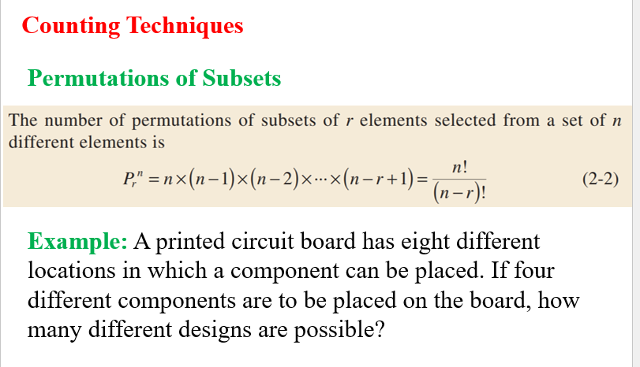
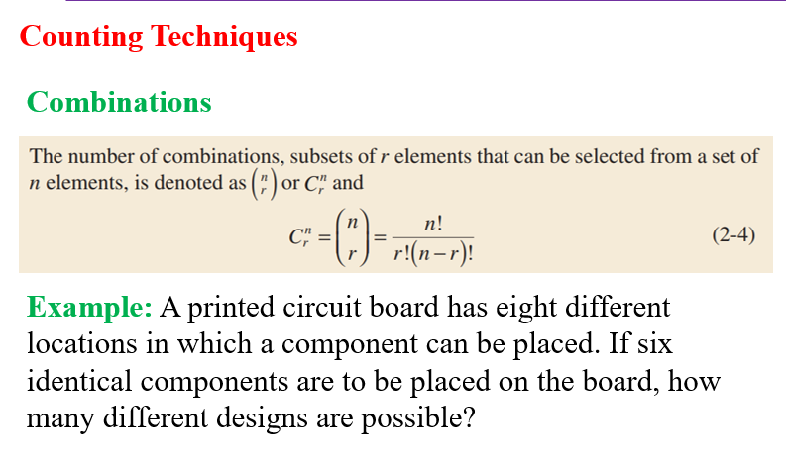

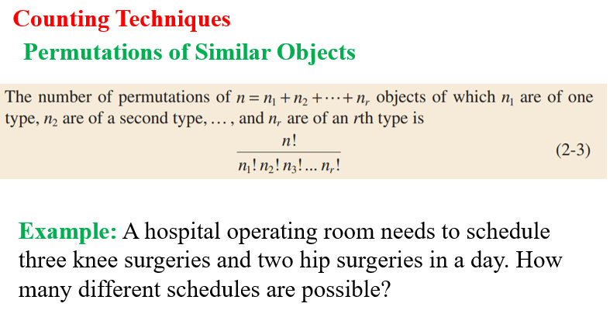

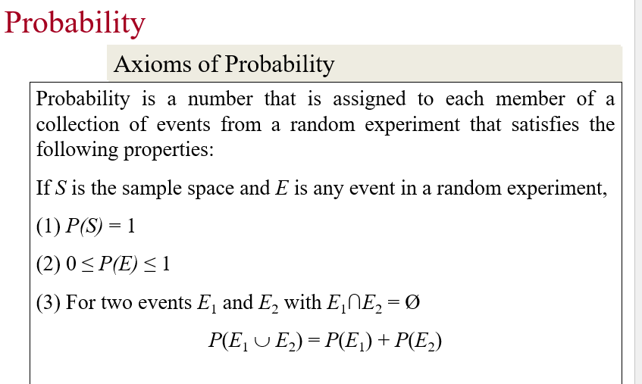

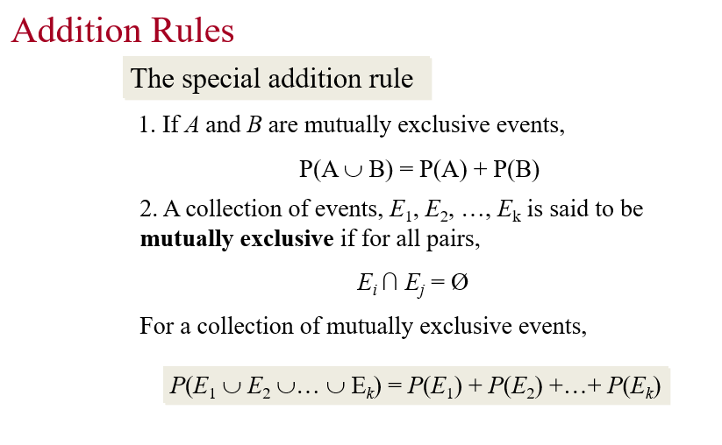
Ex: A statistics class for engineers consists of 25 industrial, 10 mechanical, 10 electrical, and 8 civil engineering students. If a person is randomly selected by the instructor to answer a question, find the probability that the student chosen is
(a) an industrial engineering major.
(b) a civil engineering or an electrical engineering major.

I industrial
M mechanical
E Electrical
C civil
- P(I)=25/53
- P(C or E)=P(C)+P(E) =

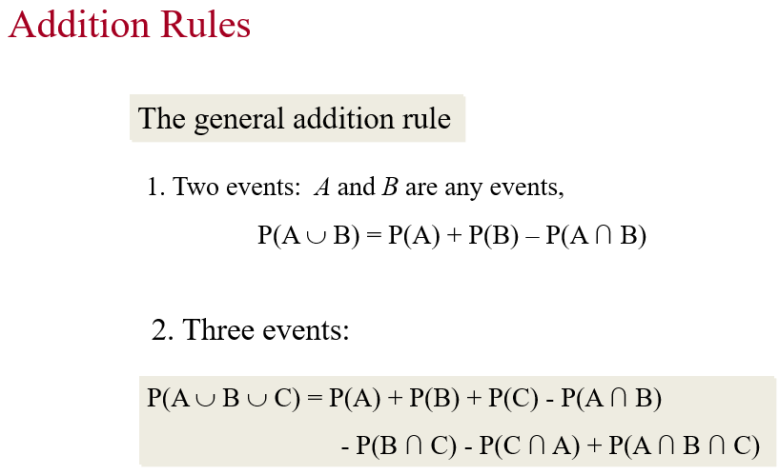

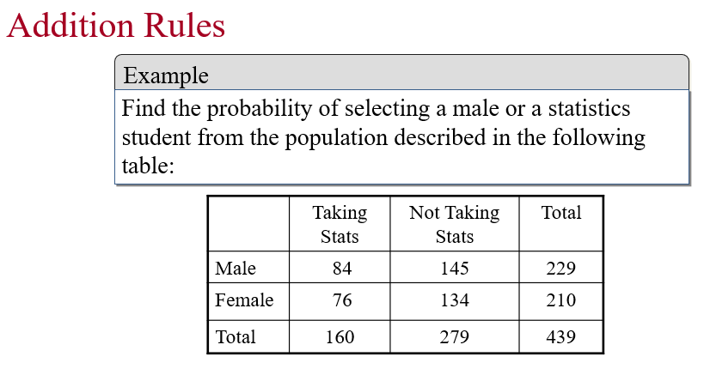

 | Taking Stats | Not Taking Stats | Total
Male | 84 | 145 | 229
Female | 76 | 134 | 210
Total | 160 | 279 | 439

Chon ra 1 SV, tinh xs de sv do la Male
$$P\left(M\right)=\frac{229}{439}$$
Chon ra 1 SV, biết SV đó Taking Statistic. Tính xs để sv đó là Male.
$$P\left(M | T\right)=\frac{84}{160}$$
Choose a student, given that this student had taken the statistic. Find the probability such that this student is male.
$P(M|T)$=????
$$P\left(M | T\right)=\frac{P(M and T)}{P(T)}$$
Conditional probability

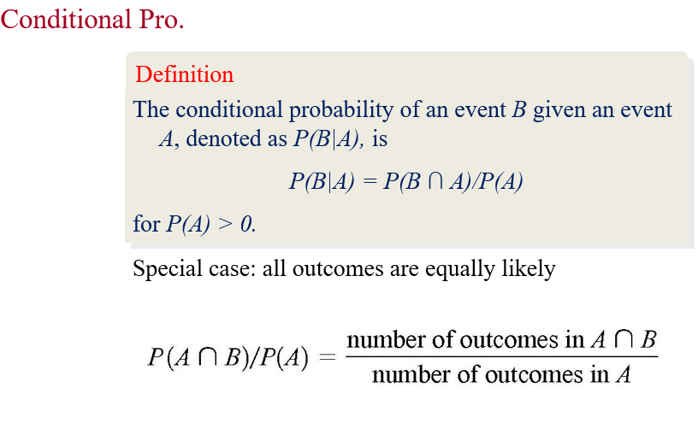

Ex: Of the cars on a used car lot, 70% have air conditioning (AC) and 40% have a CD player (CD). 20% of the cars have both.
What is the probability that a car has a CD player, given that it has AC?
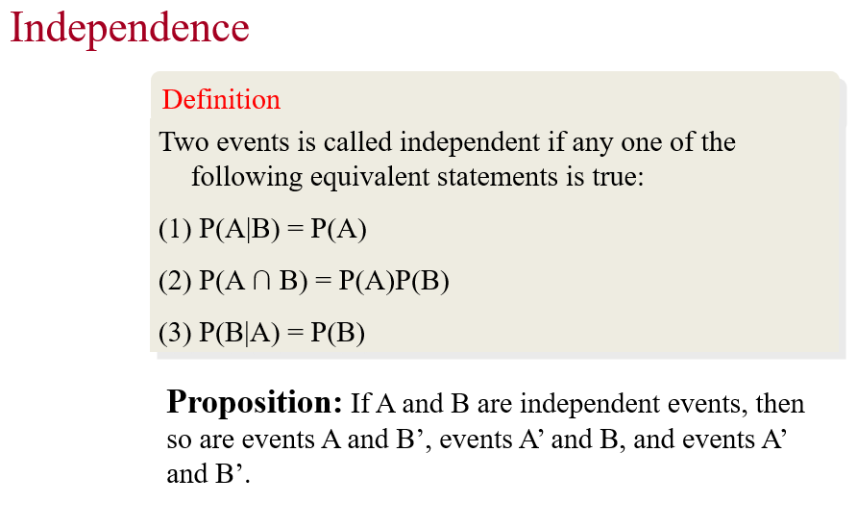
Ex:
GIVEN P(A) = 0.4 and P(A + B) = 0.7. Find P(B) if
1. A and B are mutually exclusive
2. A and B are independent events
3. P(A/B) = 0.4
4. P(B/A) = 0.5

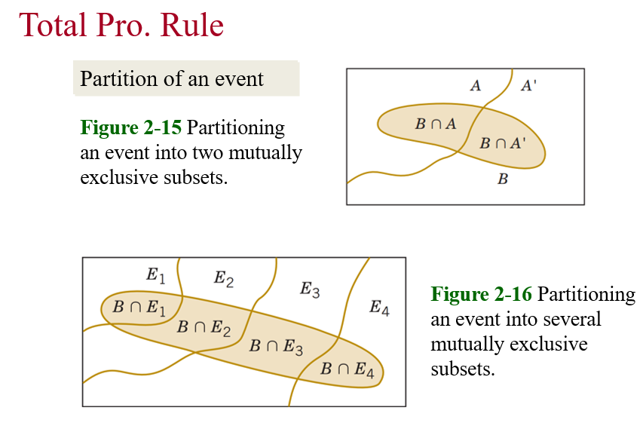

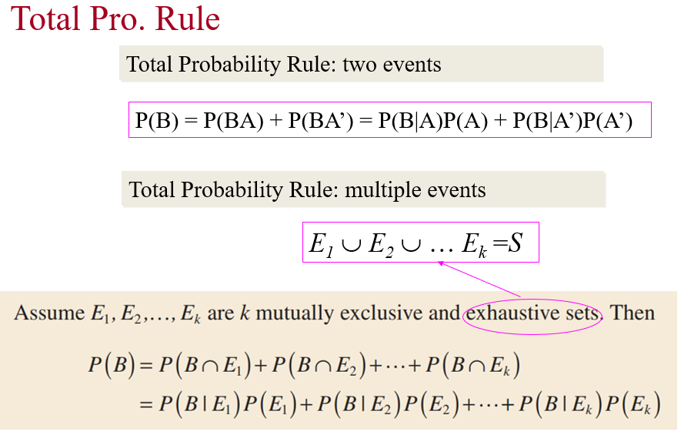
Exercises
- John is going to graduate from an industrial engineering department in a university by the end of the semester. After being interviewed at two companies he likes, he assesses that his probability of getting an offer from company A is 0.8, and his probability of getting an offer from company B is 0.6. If he believes that the probability that he will get offers from both companies is 0.5, what is the probability that he will get at least one offer from these two companies?
- Suppose 2% of cotton fabric rolls and 3% of nylon fabric rolls contain flaws. Of the rolls used by a manufacturer, 70% are cotton and 30% are nylon. What is the probability that a randomly selected roll used by the manufacturer contains flaws?

- In a certain assembly plant, three machines, B₁, B₂, and B₃, make 30%, 45%, and 25%, respectively, of the products. It is known from past experience that 2%, 3%, and 2% of the products made by each machine, respectively, are defective. Now, suppose that a finished product is randomly selected. What is the probability that it is defective?

